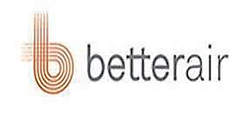

Betterair Awards & Certifications

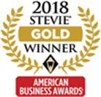

Better Air North America, LLC was named the winner of a **Gold Stevie® Award** in the “Company of the Year – Health Products and Services – Small” category at the 16th Annual American Business Awards®. BetterAir was recognized for its Enviro-Biotics™ line of probiotics that improves air quality and prolongs the cleanliness of hard surfaces. Enviro-Biotics create an indoor microbial balance, combating Sick Building Syndrome by replenishing the necessary load of beneficial bacteria. The company’s devices offer an automatic solution for a range of public and private spaces—from 200 square feet to up to 45,000 square feet—including households, gyms, spas, health care facilities, hotels, schools and transportation.

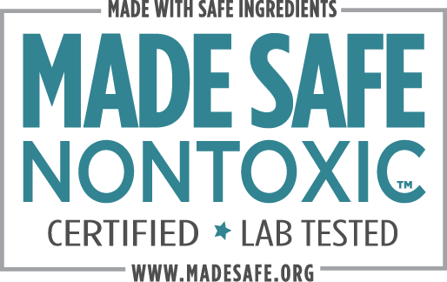

**MADE SAFE®**is America’s first nontoxic seal for products we use every day, from baby to personal care to household and beyond. We certify that products you use on your body, with your family, and in your home are made with safe ingredients not known or suspected to harm human health.

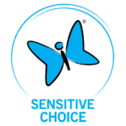

**Sensitive Choice** is a community service program created by the National Asthma Council Australia for all of us who want to breathe purer, cleaner, fresher air and reduce asthma and allergic reactions.

While the Sensitive Choice program and the products they approve do not claim to offer cures or treatment for such conditions, they conscientiously strive to help cleanse and purify the personal environments in which we all live and breathe.

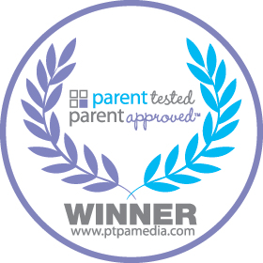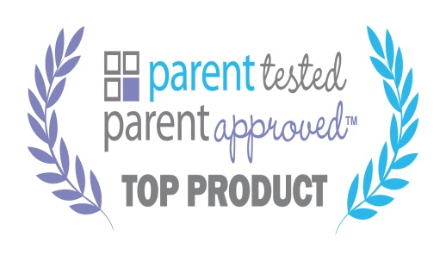

**Parent Tested Parent Approved** takes the guessing game out of shopping for your family, and when purchasing a product with this seal you can feel confident knowing that **other parents have tested and approved** of that product.

**Betterair has not only received PTPA’s Five Star rating but has also received PTPA’s Top Product Award for 2020!**

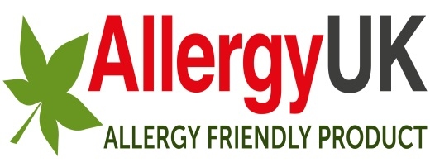

**Allergy UK** is a leading health charity (a non-profit organization) and have been helping people affected by allergy, sensitivity and intolerance for over 25 years now. There is no cure for allergy, so advising people about useful products which can help alleviate some of the pain and pressures associated with allergy, is part of what we do to help make lives more comfortable for people living with allergic conditions.

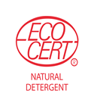

The **EcoCert** Ecological cleaning products certification is intended for producer of raw materials and manufacturers of household care products brands. The Ecological cleaning products certification guarantees: environmentally friendly production and processing processes, promotion of the use of natural or organic ingredients, responsible management of natural resources and prohibition of most of petrochemical ingredients.